Wizard 5 Race

Tuesday July 28th, 2026, 7.00pm Start

RUNNER’S GUIDE

The Race
A 5 mile multi-terrain race on the quiet lanes, tracks and trails of Alderley Edge. The terrain varies from grassy and muddy path to hard tarmac but is mostly good going on quiet roads and surfaced trail. The route includes the beautiful woodland and hills of the Alderley Edge and Hare Hill National Trust estate. The race distance is approximately 5 miles but the terrain does not permit the accurate measurement required for a UKA distance certificate.
After rain there will be muddy puddles and some slippery gravel sections so please take care. On road sections run on the left and always follow marshal’s instructions.
The route will be marked with red/white tape and signs and marshals will direct you at key junctions.
Route map trace at: https://www.strava.com/activities/1082105215
The race is organised by Wilmslow Running Club and is licensed by the TRA and held under UK Athletics Rules Licence Number
All the proceeds will go directly to Save The Children and a contribution to the National Trust for their supporting the event
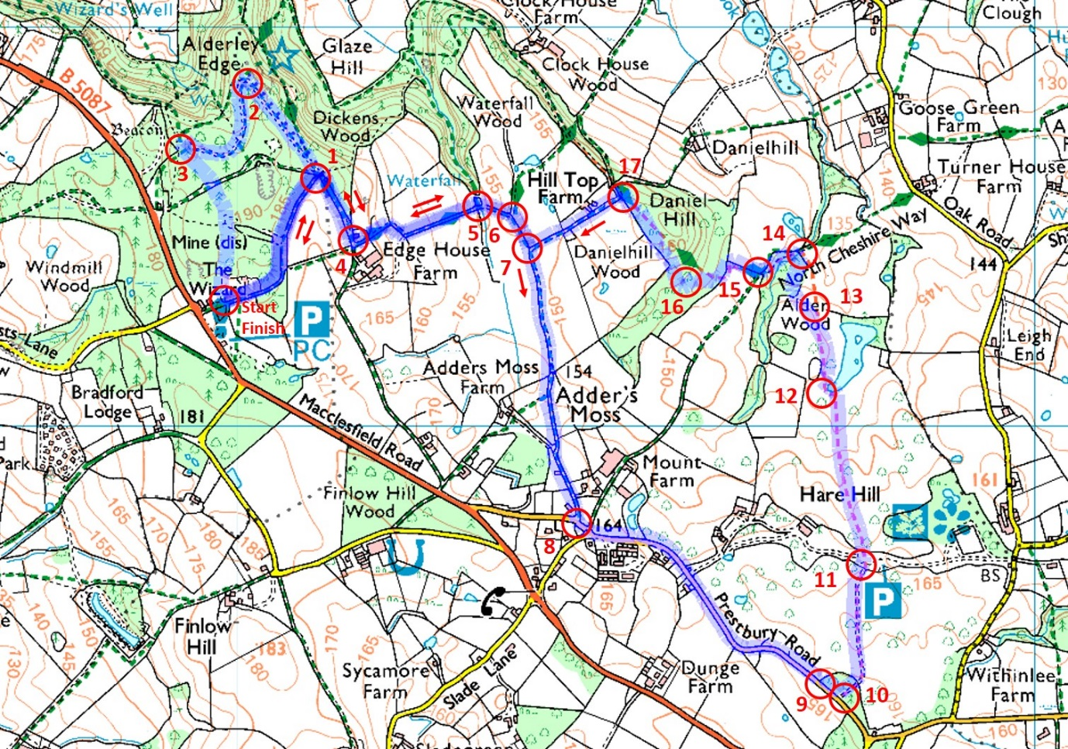

THE Race is likely to be fully booked on line, no entries on the night will be possible.

Entry and timing are provided by Nifty

If you can no longer run and wish to transfer your entry to a friend then you should use the online system at https://wilmslowrc.niftyentries.com/Wizard5-2025 Transfers are £3 and available until 1 day before the race. The website will also allow you to cancel your entry and receive an 80% refund until 7 days before the race. The small charges cover the admin costs.

Race HQ, Parking and Start Area
The event is centred on the National Trust car park at Alderley Edge and uses the NT buildings and facilities adjacent to the car park.
Macclesfield Road, Nether Alderley SK10 4UB
As you drive into the car park the Race HQ, number collection and start is to the left, toilets to the right.
Parking is limited to the NT car park so please car share. It is also easy to cycle or jog from Alderley Edge train station – approximately 2 miles. Parking is free for runners in the NT car park. Note that the car park will be locked around 9.30pm so don’t go off on a long warm down and pub.
No parking at the Wizard Inn or on the main road. There is some parking in lay-bys and further along the road towards Macclesfield.
You may leave kit bags near the start but please be aware that we can’t be responsible for your kit or valuables.
We keep costs to a minimum to maximise the donation to charity, so there is no goodie bag, medal or t- shirt, just the warm glow of having taken part in a great little race. There will be water – one bottle each – but nothing else so please bring your own snacks and drinks.
The Wizard Tea Room will be open serving hot and cold drinks

Safety Briefing
The route is marked with red/white tape. Stick to the route and stay on the marked footpaths at all times. Anyone taking a shortcut is not playing the game, not enjoying the full route and will be DQ’d.
Be aware that the roads are open to traffic. Most are quiet lanes but there may be some local traffic. Run on the left hand side of the road sticking to the pavement as far as possible. UKA rules stipulate that headphones must not be used in races where roads are open to traffic.
Please take care on slippery sections, over stiles and through narrow gaps. Give your fellow runners and other pedestrians room on narrow sections.
At Hare Hill between points 11 and 12 on the map you run across a farmer’s field. There will be cows in the field, hopefully not on the path. Please stick to the marked course and follow marshals instructions. If your way is blocked by cows then find a diversion around them and slow down – preferably walk calmly until you are past them.
First Aid is provided by Cats Eye Medical, who will be primarily available in the start / finish area. If you encounter an ill or injured runner then please report to the nearest marshal. Please obey all marshal’s instructions and report any incidents to them. If you retire from the race, please inform a marshal - give them your name and race number – so that we do not send out a search party!
We are sharing the paths with any members of the public out for a walk so please go carefully, be friendly and give way when appropriate.

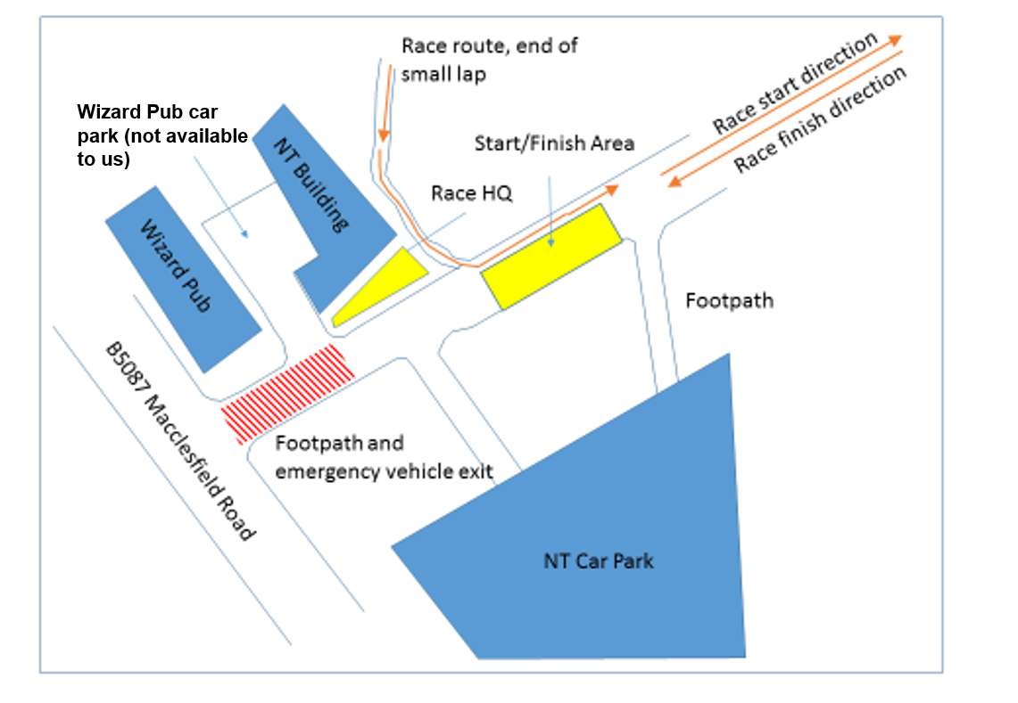

Results
Results will be posted on Nifty Entries and PowerOf10.
There are prizes for first 3 males and female plus category prizes and teams (3 to count). Category prizes are awarded gender equal from V40 in 5 year intervals up to including the oldest competitor. Prizes are Run Northwest vouchers. Presentations by the finish.
There will be an interclub team competition. Each team will be of four runners, including two men, two women, one person who is aged under 35 years and one person who is aged over 60 years

All Proceeds To Charity

All the proceeds of the race go direct to charity

This year our charity partners are:
The National Trust, Alderley Edge and Hare Hill
Save The Children

Big Thanks To

The National Trust for permission to run over the estate and use of their parking and toilet facilities
Mount Farm for their support in allowing the race across their fields
Run Northwest – sponsoring the race numbers, donated vouchers and other goodies.
Catseye Response Medical Services
The Wizard Tearoom
And of course, to all the good people at Wilmslow Running Club who make the event happen

Finally …

We hope that you have a great run and enjoy the evening.
Tim Billington
Race Director
Wilmslow Running Club
trackwrc@gmail.com

Race licence England Athletics 30941


